Functional & Performance Testing Template
Model Performance Test
Field | Details
Date | 28 September 2026
Team ID | SWTID-2026-4815
Project Name | Implement Client Script & UI Policy (Incident)
Maximum Marks | 4 Marks

Test Scenarios & Results
Test Case ID | Scenario (What to test) | Test Steps (How to test) | Expected Result | Actual Result | Pass/Fail
FT-01 | Test Mandatory Enforcement | Create new Incident, set Impact = High, leave Assigned To empty, click Submit | Save blocked, error message shown for Assigned To | Save blocked with error | Pass
FT-02 | Test Successful Save | Fill Assigned To field with a user, click Submit | Incident saves successfully, no errors | Saved successfully | Pass
FT-03 | Reverse Condition Test | Open existing Incident with Impact = High, change to Medium | Assigned To no longer mandatory; Urgency becomes editable | Reverted correctly | Pass
FT-04 | Test List Edit Blocking | In Incident list view, double-click State field to edit inline | Alert appears, State value unchanged | Blocked with alert | Pass
FT-05 | Test Form-Based Update | Open Incident, change State via form, click Update | State change saved successfully; Assigned To/Urgency rules still apply | Saved successfully | Pass
FT-06 | onChange Urgency Auto-Set | Change Impact field to High on the form | Urgency automatically sets to High with info message | Urgency auto-set correctly | Pass
PT-01 | Client Script Response Time | Change Impact field, measure time to update Urgency | Should update in under 1 second | Updated instantly (<1 sec) | Pass
PT-02 | Form Load Performance | Open Incident form multiple times, check load time | No noticeable lag due to UI Policy/scripts | No lag observed | Pass

Test Evidence (Screenshots)
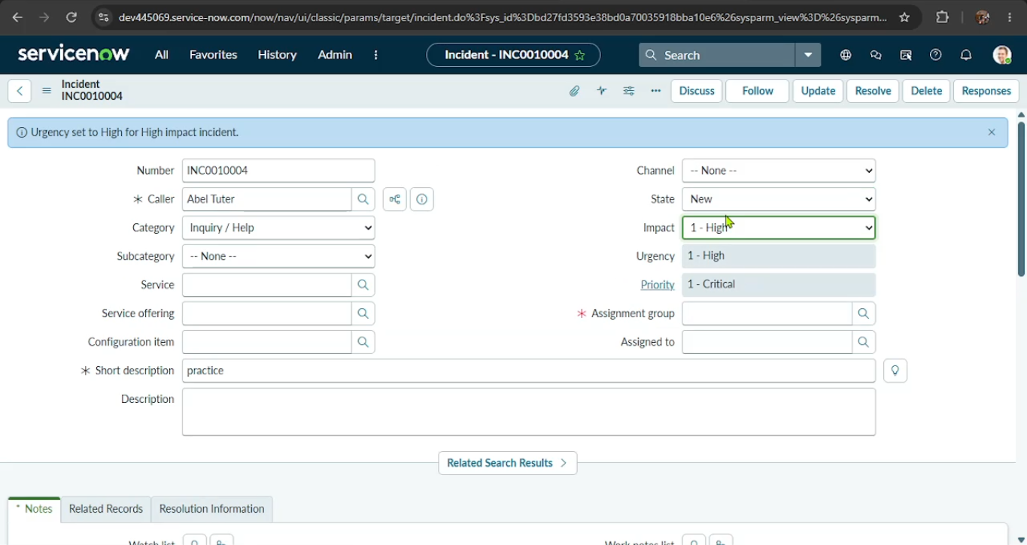
Figure 4: Impact set to High - Urgency auto-set to High (read-only) with info message
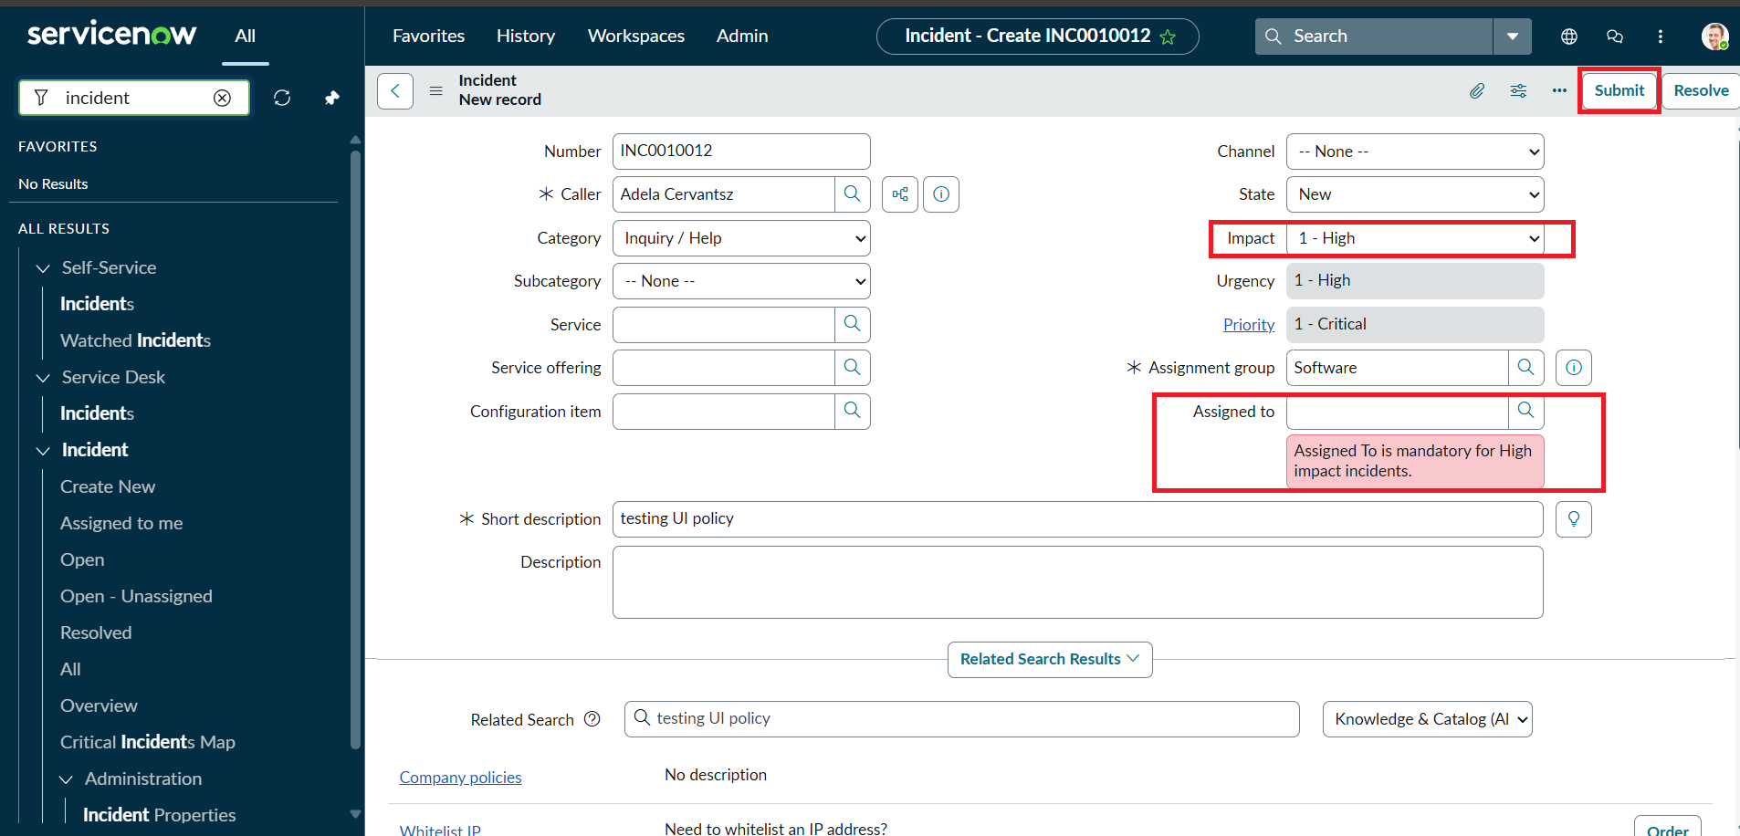
Figure 5: Activity 1 - Save blocked, error 'Assigned To is mandatory for High impact incidents'
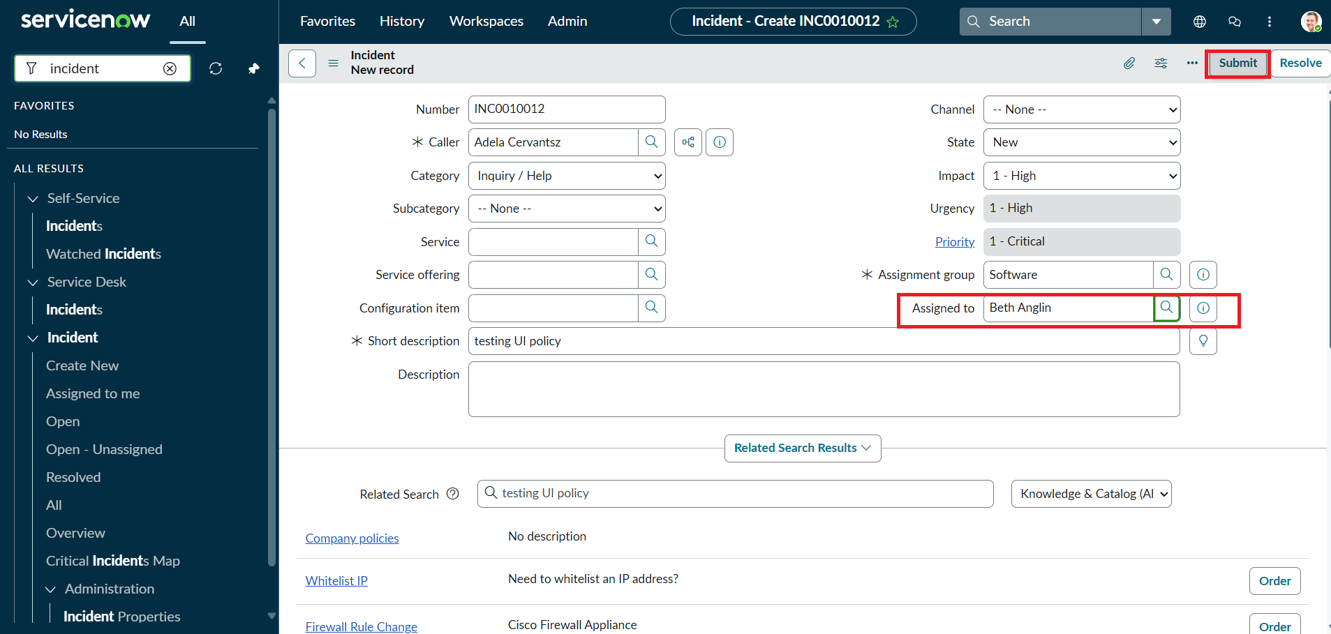
Figure 6: Activity 2 - Assigned To filled, Incident ready to submit successfully
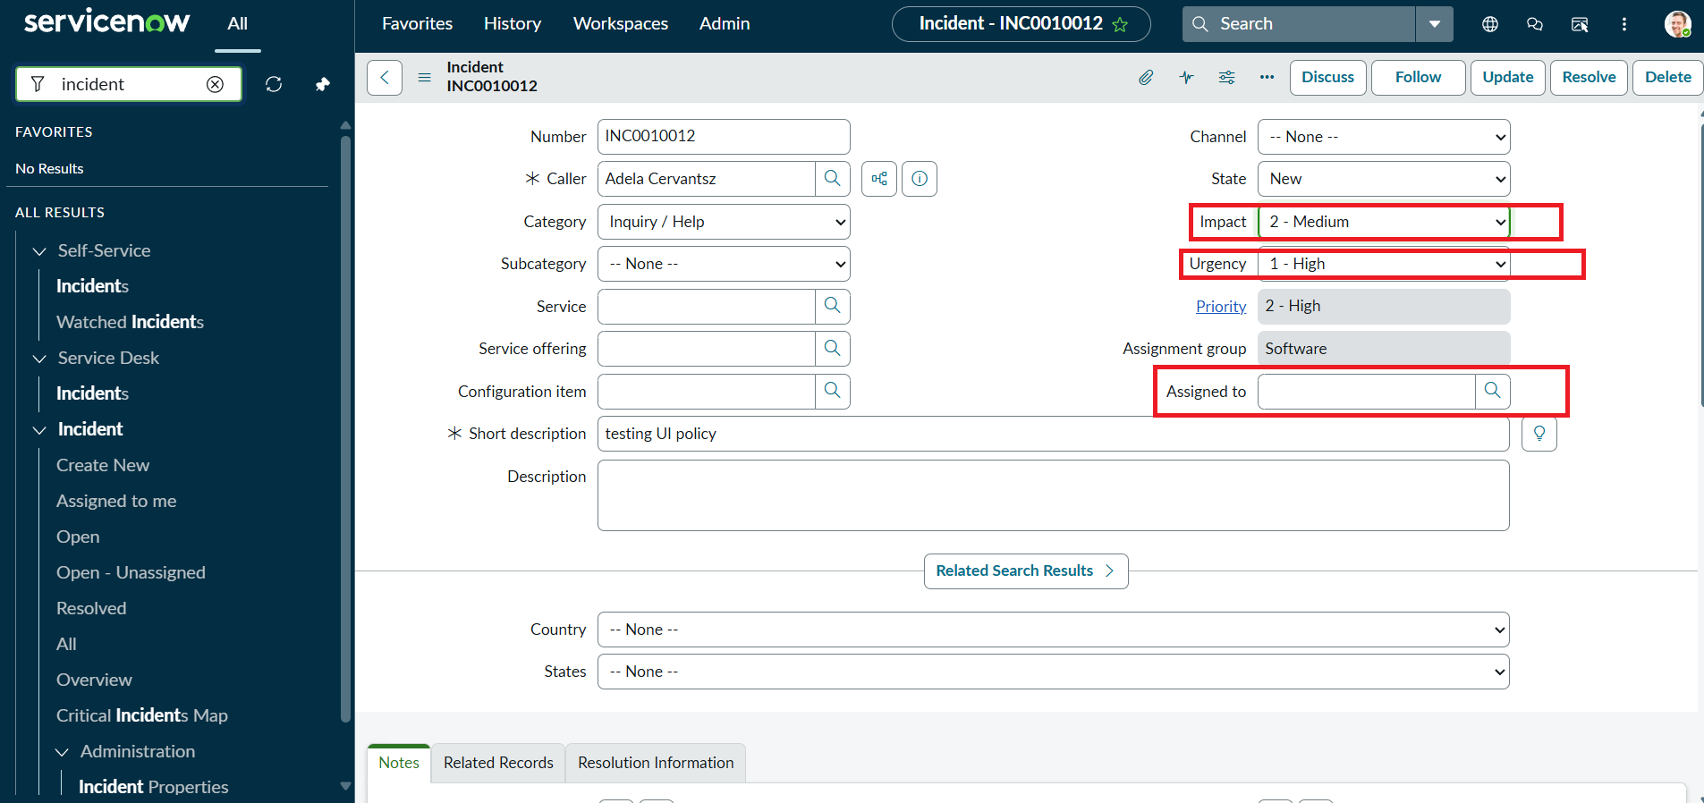
Figure 7: Activity 3 - Impact changed to Medium, Urgency becomes editable (reverse condition)
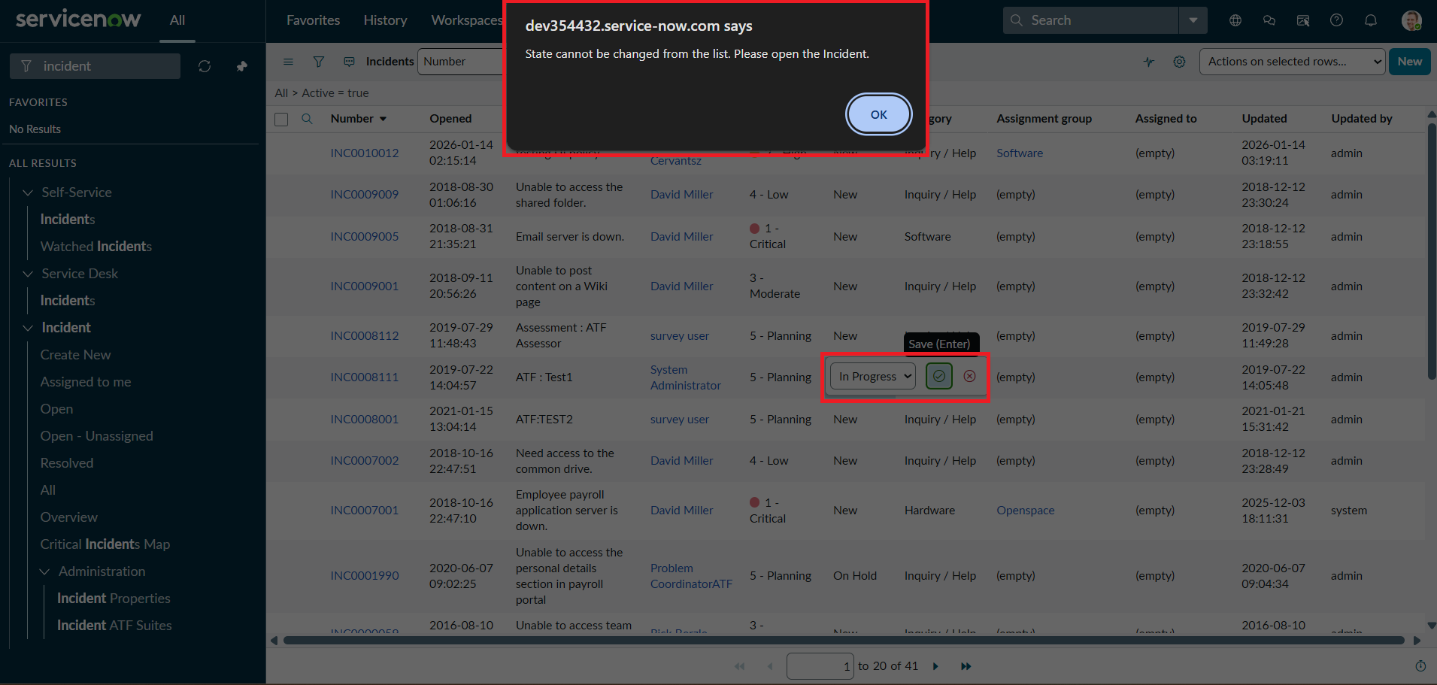
Figure 8: Activity 4 - List view State edit blocked with alert message

